EPG - Merchant JWT Token Creation
Integration Guide
- EPG (Sandbox) URL: https://sndbx-epgapi.taly.com.eg:5002/swagger/index.html

- Step 1:
- Merchant will receive Zip from taly team and password to extract the file content.

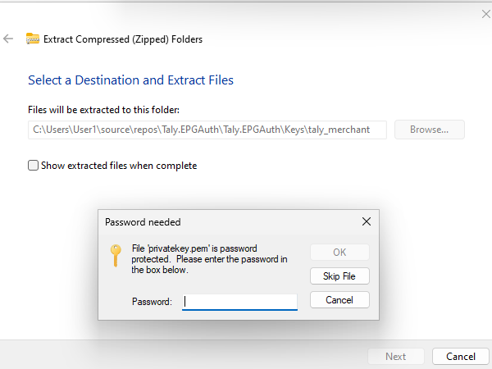

- Step 2:
- There will be 2 main files after extraction:
Publickey.txt
Privatekey.txt
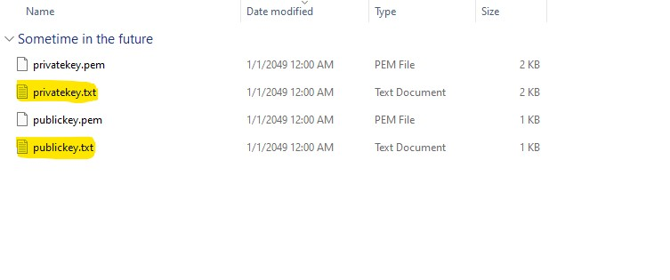

- Step 3:
- Development team at Merchant will call Key API using string at Publickey.txt and merchant login name (already used at .zip file name [ex: taly_merchant]) to generate “kid” parameter
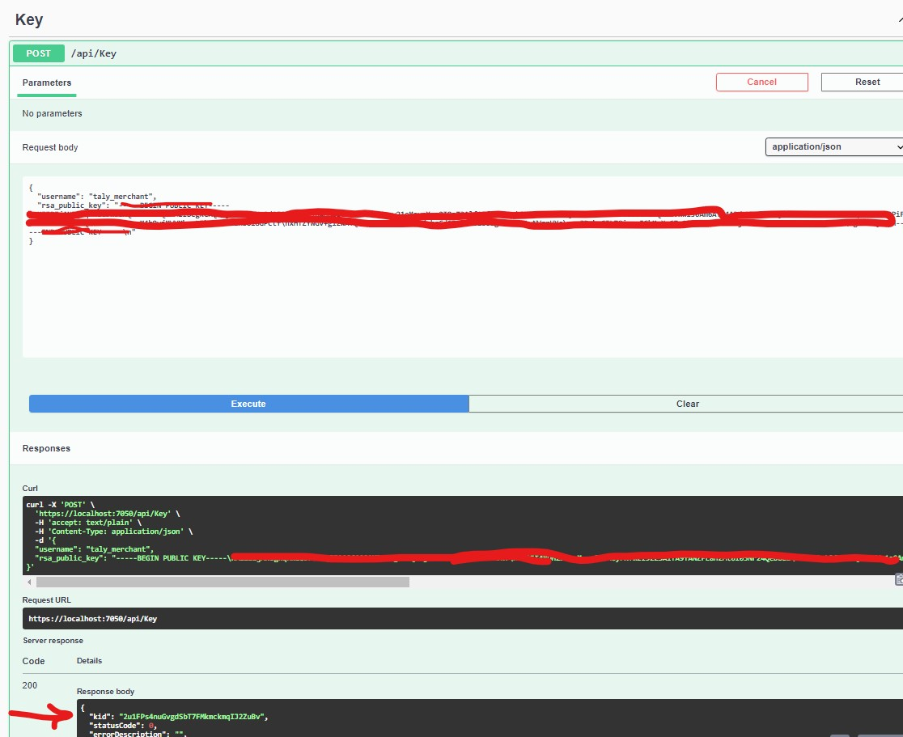

- Step 4:
- Development team at Merchant will call CreateJWT using “kid” parameter from step 3 beside string at Privatekey.txt to generate “Jwt” token.
